 | ​ | 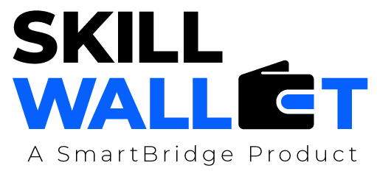
Scalability & Future Plan
Date July 7, 2026
Team ID 12344
Project Name Opticrop
Maximum Marks | 1 Mark
Opticrop - Scalability & Roadmap
Scalability & Future Plan:
Short-term (3 months)
This document outlines how the current project solution can be scaled to handle larger user bases, REST API for IoT soil sensors (real-time NPK feeds)
increased data loads, or extended features in the future. It also captures the team's roadmap for Multi-language support (Hindi, Telugu, Tamil)
enhancing and evolving the project beyond its current state.
Mid-term (6 months)
Weather API integration for automated irrigation alerts
Current System Limitations:
Mobile-responsive PWA with offline mode
S.No | Limitation  Long-term (12 months)  Leaf-disease CNN (PyTorch) via camera uplo | Impact  ad | Priority to Address  (High / Medium / Low)
1 | SaaS multi-tenant login (farmer history & tren Govt. API linkage for subsidy eligibility checks | d analytics)  s
2
3
Scalability Plan:
S.No | S.No Scalability Aspect | Current State | Proposed Upgrade / Solution
1 | User Load
2 | Data Storage
3 | Performance
4 | Security
Future Roadmap:
Phase | Planned Feature / Enhancement | Target Timeline | Expected Impact

Phase 2
Phase 3
Phase 4

